**Title Page**

**Contents**

**1.0 Executive Summary**

This SEED Lab Report explored the processes, observations, key learnings and outcomes of conducting various labs. This included exploring RSA public and private encrypting and decrypting in various scenarios. Secondly conducinting variations in attacks on a Buffer Overflow vulnerability within code. The final lab consisted in exploring the effects of a TCP RST attack on Telnet, SSH and TCP connections.

**2.0 Introduction**

The SEED Ubuntu version 16.04 VM was set up on the Virtual Box application, installed On a windows 10 environment.

**3.0 Objectives**

**RSA Lab:**

After completing this lab the main takeaways included computing the private key given public key using the RSA key generation equation. Furthermore how to encrypt a string message from plaintext to ciphertext using the RSA encryption equation. From the third task the process of decrypting ciphertext into plaintext using the decryption process was understood. In the fourth task it was understood the process of adding an RSA signature to a transmitted message, using the RSA signature equation. From the final task, it was learnt the process of verifying an RSA signature using the signed message RSA equation. Furthermore, another major takeaway was the usefulness of the ‘BIGNUM’ API in computing large numbers with a modulus to determine unknown RSA variables in public/private key encryption and decryption.

**Buffer Overflow Lab:**

From completing this lab the first key understanding was how to compile and execute c shellcode, whilst also understanding how turning off the non-executable stack and address space randomisation allowed for launching a shell. From the second task the key takeaway was the vulnerability of turning off the stackguard protection countermeasure allows for attackers to write more bytes into the buffer and execute malicious code. Finally from task three it was learnt the significance of the ‘setuid’ statement in leaching a root shell as a root user.

**TCP/IP Attack Lab:**

From the first task the key learning was the importance of the SYN-Cookies protection as a countermeasure in attackers perfroning a SYN-Flood attack between a user and server/client. After completing the second task it was learnt how powerful conducting an RST TCP attack on Telnet and SSH connection, in closing a connection between two entities. Finally, in task three it was learnt the network influence of the RST TCP attack on video streaming applications, with how the attack caused buffering on the victims streaming interface.

**4.0 Timeline**

Date completed for each of the SEED lab tasks are illustrated below:

1. **RSA Public-Key Encryption and Signature Lab:**

* Task 1: 25/08/2020
* Task 2: 25/08/2020
* Task 3: 25/08/2020
* Task 4: 26/08/2020
* Task 5: 26/08/2020

1. **Buffer Overflow Lab:**

* Task 1: 28/08/2020
* Task 2: 29/08/2020
* Task 3: 29/08/2020

1. **Attacks on TCP/IP Protocol:**

* Task 1: 29/08/2020
* Task 2: 30/08/2020
* Task 3: 01/09/2020

**5.0 Processes & Results**

**5.1 RSA Public-Key Encryption & Signature Lab**

**Task 1 Deriving the Key**

This task incorporated calculating the private key ‘d’, given the hexadecimal values of ‘p’, ‘q’ and ‘e’. Making use of the ‘BIGNUM’ API library in the process of RSA cryptography. The first step involved writing a script (Figure 1) which firstly converted the hex values of p,q and e to assign as a value in memory for later calculations. The first step in deducing the value of the private key is to calculate $Φ(n) = (p-1)(q-1)$. The values for ‘q-1’ and ‘p-1’ were done using the BIGNUM subtraction function and stored. The next step was to determine n = pq, to do so the BIGNUM addition function was used to to determine this. Finally by applying the known RSA key generation equation $d∙e = 1 mod Φ(n)$. The value of the private key d then can easily be computed and calculated using the BIGNUM modular inverse function. 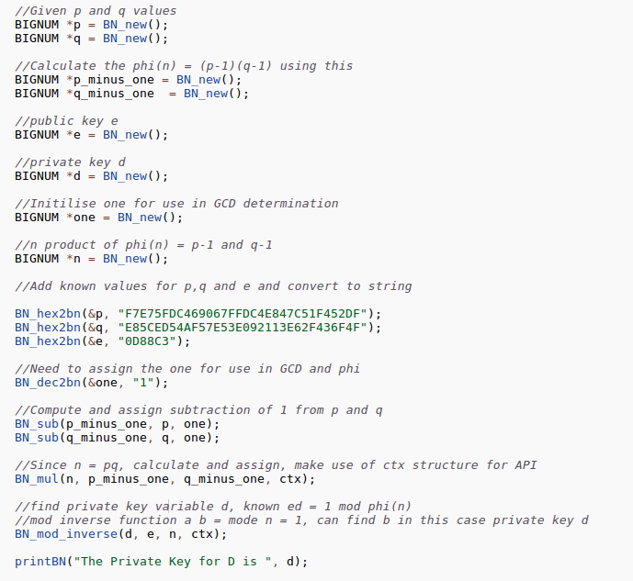

*Figure 1:*

Once the script was written it was compiled using the crypto library, this link ensured that the script can be compiled. The output of the private key ‘d’ is evident below in Figure 2. The interesting observation is the ease of computing the private key in solving the equation $d∙e = 1 mod Φ(n)$, which mathematically is highly complex, however using this computational script it can be deduced quickly, and any change in the public key (e, n) can be changed to find any other private key.

*Figure 2*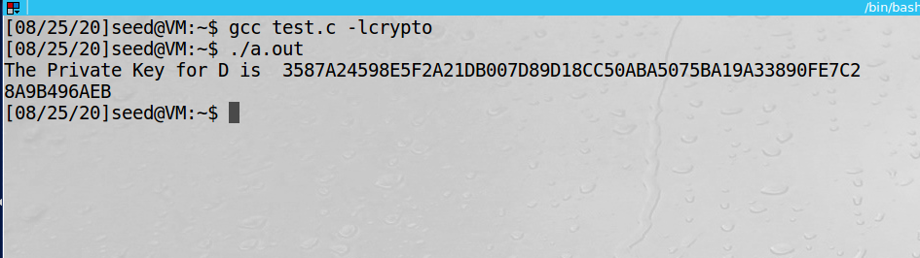

**Task 2 Encrypting a Message**

Given the public key (e, n), private key d and the message “A top secret!”, this task involved encrypting this message which would be a transformation from plaintext to ciphertext which could be used before transmission. The first task involved converting the plaintext message to hexadecimal string to be used in the BIGNUM API library. This involved running the following command in the terminal (Figure 3).

*Figure 3*

Using this value, the given n, plaintext, e and d hexadecimal string values were assigned to defined variables in memory. The RSA encryption algorithm equation is given by e n.

The cipher text C can be computed using the BIGNUM function ‘BN_mod_exp’ the cipher text for the message is calculated using the message and public key (e,n). Going further it was important to understand whether the reverse can be applied to decrypt the ciphertext back to plaintext, which would confirm the correct process of RSA message encryption. Hence by using the same BIGNUM function with the decryption equation m = cd mod n. This deduced a hexadecimal string value for transforming the ciphertext back to the hexadecimal string for the plaintext message (Figure 4).

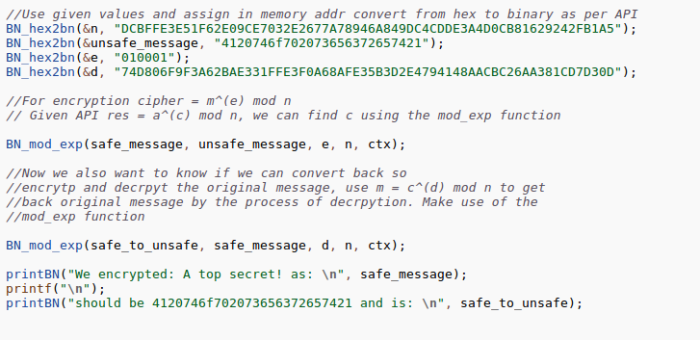

*Figure 4*

By compiling the script (Figure 5) the encrypted value can be printed for the plaintext. To confirm it was observed that decrypting the cipher text returned the same headcuimal string value as started out with. Reflecting back on this it was surprising that knowing the encrypted message, n and d, the cipher text can be easily transformed back to plaintext via the RSA decryption algorithm.

*Figure 5*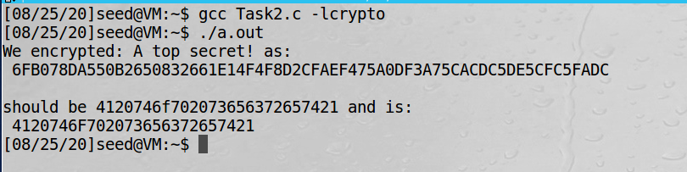

**Task 3 Decrypting a Message**

The message decryption task involved a given ciphertext in the form of a hexadecimal string. The step was to assign the ciphertext and public/private key values to variables in memory. This was then used in the equation m = cd mod n, which is solved for ‘m‘ using the BIGNUM API function.

*Figure 6*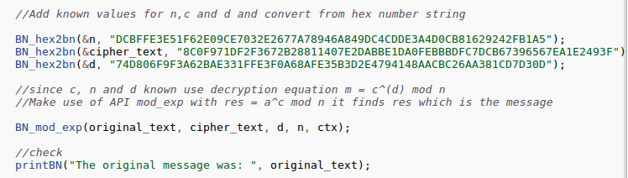

The script was compiled and it was observed that a RSA decrypt hexadecimal string was outputted from the computation (Figure 7).

*Figure 7* 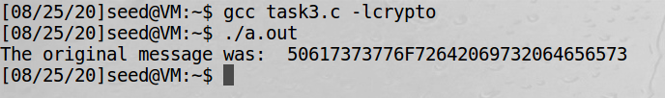

To interpret what the decrypted message is in plaintext, python was used to convert the hexadecimal string to plaintext human readable string. The message decrypted was “Password is dees”. An interesting observation was the ease of using the RSA equation and known public/private keys variables to decrypt sensitive ciphertext information.

*Figure 8*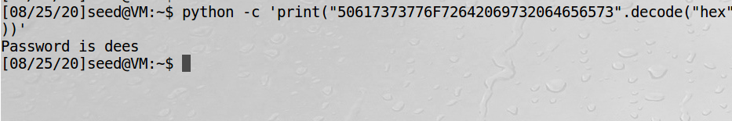

**Task 4 Signing a Message**

This task involved using a given public and private key values to create a signature to be appended onto a message sent. The main interesting concept from this was that the purpose of adding a signature is to authenticate the sender. The first step involved converting both the plaintexts of “I owe you $2000.” and “I owe you $3000.” to a hexadecimal string. This was done using the python function in the shell to make the conversion, enabling variable memory assignment (Figure 9 & 10).

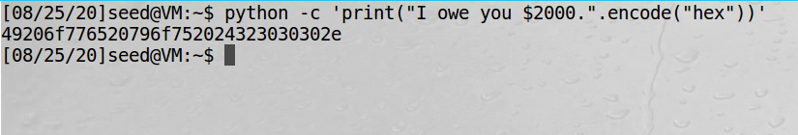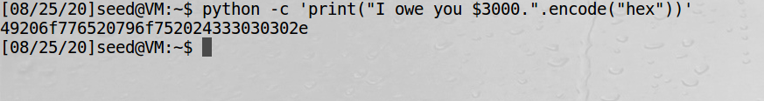

*Figure 9*

*Figure 10*

One converted to a hexadecimal string, the message was able to be stored in memory using the BIGNUM API function. To generate an RSA signature the equation S = md (mod n), where ‘S’ is the signature code, ‘m’ is the plaintext message, ‘d’ is the private key exponent and ‘n’ is the public key value. This RSA signature code was then computed using the BIGNUM function ‘BN_mod_exp’, which will calculate the value of S (Figure 11).

*Figure 11: RSA Signature for $2000/$3000 message*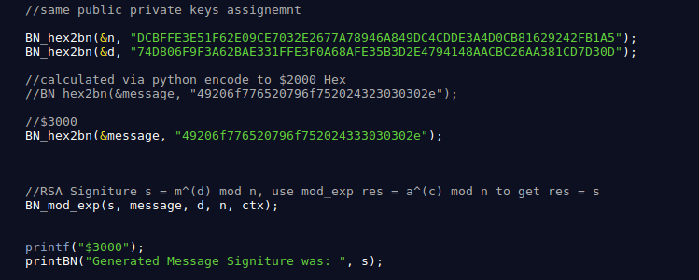

This code was then compiled for both messages of $2000 and $3000 in the shell (Figure 12). The most interesting observation made from this was that changing one character produced significantly different RSA signed messages. The key takeaway from this, is that the RSA signing algorithm produces a signature that is difficult to identify patterns and ensure authenticity with the senders signature.

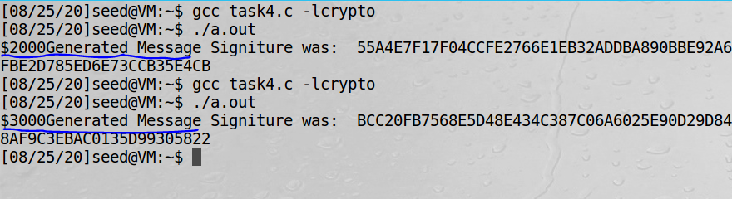

*Figure 12*

**Task 5 Verifying a Message**

The first part of the final task required a received message from Alice in the form “Launch a missile.”, to verify that the signature was truly Alice’s. The given information was the received message (m), message signature (s) and Alice’s public key (e,n). To utilize the BIGNUM API’s functions, the message needed to be converted to a hexadecimal string format using a python command in the shell (Figure 13).

*Figure 13*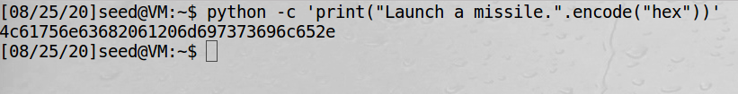

This value alongside Alice’s public key values was stored in memory, using the BIGNUM function. Next, to verify the RSA signature of the message use the equation m = Se mod (n), where m is the signed message, n is the public key exponent to find ‘S’ (Figure 14). The BIGNUM function will compute a value for the signature (S) . An interesting observation is that this verification process only works since the public key is used also in the signing process, hence it will work in the verifying process as well.

*Figure 14: Verification of 2F & 3F*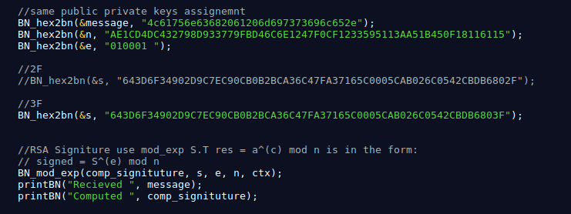

By executing this code in the shell, RSA signature verification can be made by printing out the received original signature and the computed signature, which uses both the original signature and public key exponent to produce a value. If the computed signature matches the received singitute, then it can be concluded that the message is RSA verified ro have originated from Alice. By firstly leaving the last two characters as 2F, it is evident that all the characters match for the first message for the computed and received message. Hence, it can be concluded that the first message was from Alice (Figure 15). The not surprising observation was when using the corrupted signature of 3F, this when computed didn’t produce a match with the original signature. This was expected, as the algorithm mathematically computes the signature using the public key exponent and original signature. Thus, any changes to the original signature will propagate into the verification process of the signature, producing an incorrect match to the original message. This implies that the added 3F characters cannot verify the RSA signature of the received message as from Alice (Figure 15).

*Figure 15: RSA Signature Verification for 2F and 3F*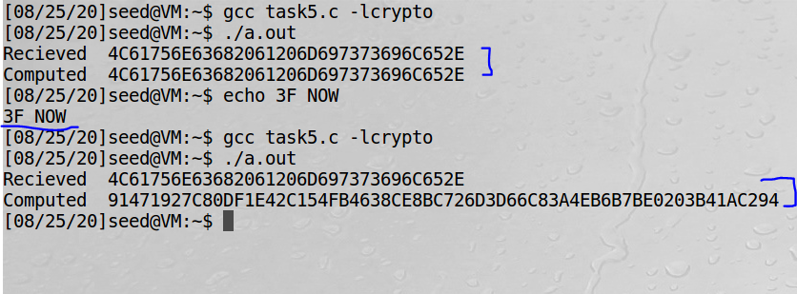

**5.2 Buffer Overflow**

**Task 1 Running the Shell Code**

The first task involved running the shellcode ‘shellcode.c’ within the terminal. To do so, the ‘.c’ file was saved and placed in a file location (Figure 16).

*Figure 16:*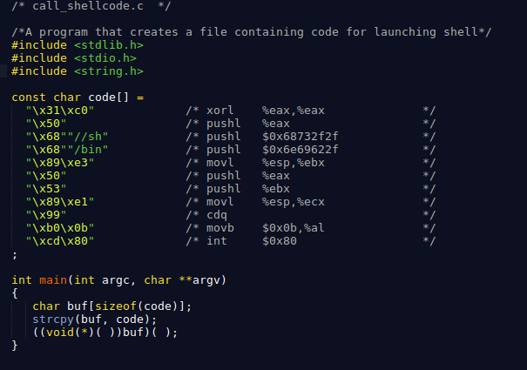

It can be observed that to run this shellcode the address space randomization was required to be disabled. The purpose of this was that this function being on randomizes the starting point of the heap and the stack, which interestingly makes guessing any address difficult (Figure 17).

*Figure 17*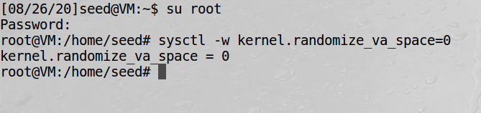

Next multiple flags were required for compilation and execution. This included the ‘execstack’ function and ‘-o’ and ‘-z’ flags, doing so allows executable stacks in Ubuntu. Once calling the executable file, the code is executed from the stack. It can also be observed that the void(*) function itself invokes a shell waiting for an input (Figure 18).

*Figure 18*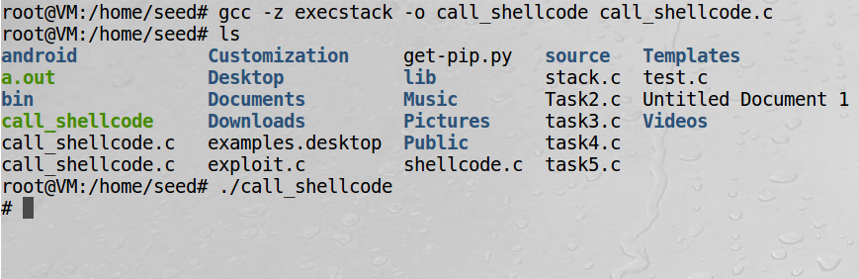

Another observation made was that the instructions code contains //sh and /bin to the stack (Figure 16). This is interesting as the ‘/’ and ‘//’ have the same interpretation, hence the instruction can be read as /bin/sh. The rest of the code then invokes the system call to execute the /bin/sh which at this point doesn’t do anything aside from launching a shell.

**Task 2 Exploiting the Vulnerability**

The next task involved exploiting the buffer overflow vulnerability in the stack.c file. The aim was to write more data into the buffer then the buffer should allow in the vulnerable code. The task also gives the file exploit.c which outputs a ‘badfile’, and if successful gets imported by ‘stack.c’ to write to one of its buffers. It can be observed the main problem with the stack.c code, is that the buffer has 24 characters available, with the vulnerability allowing a maximum of 517 characters to be overwritten. The first step is to compile the vulnerable program stack.c by switching to root mode and turning off the stack guard. An interesting observation made was that Stackgaurd exists when compiling with gcc to prevent buffer overflow situations. The next step is to change the mode of the program using ‘chmod 4755 stack’ which allows the program to launch a shell in root mode, hence gain root shell access (Figure 19).

*Figure 19*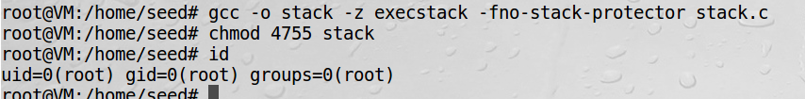

The next step is to overwrite some bytes in the badfile. This process involved making use of GDB in the stack.c file to gain access to the address after the base pointer (ebp) and stack pointer (esp) (Figure 20).

*Figure 20*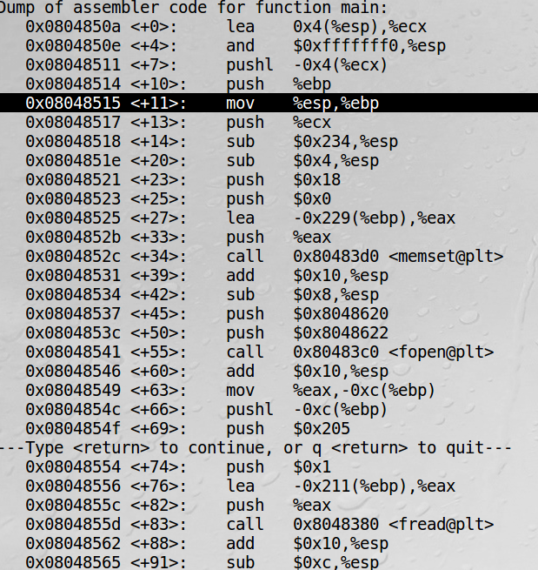

Next the address ‘0x08048518’ was selected because it was just after the base pointer (ebp) and stack pointer (esp). One selecting this address a breakpoint was set to determine the location of the base pointer (ebp). Using this breakpoint (Figure 21 & 22) the address of the base pointer (ebp) could be printed with the line ‘i r $ebp’.

*Figure 21*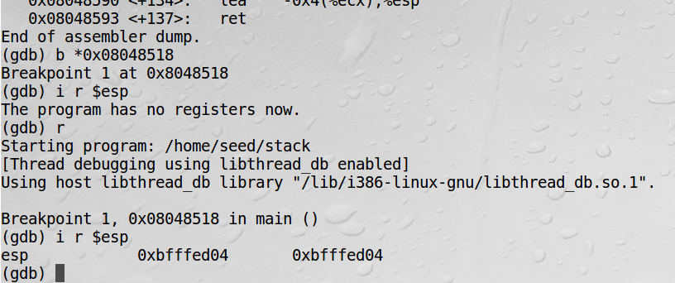

*Figure 22*

Given this base pointer address, it can be observed that the return address is ‘0x4’ above the base pointer address (Figure 23). Converting this to decimal is 4 bytes above the base pointer. 

*Figure 23*

Interestingly the return address needs to exist within the NOP instructions, and will continually execute NOP instructions until the shellcode is reached. Hence by factoring in return address being 4 bytes and the base pointer is ‘0xbfffed04’ add some arbitrary 100 bytes which should be an address within the NOP instructions, which do nothing and move onto the next instruction. Doing so, gave the address ‘0xbfffeaa1’, which was overwritten these 4 bytes in the exploit.c badfile, and the shellcode being appended at the end of this badfile (Figure 24).

*Figure 24:*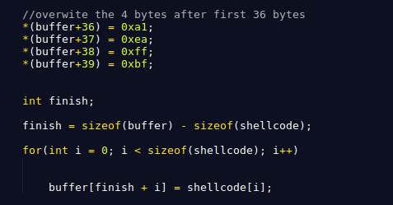

After modifying the buffer, the exploit.c file was also compiled and both stack.c and exploit.c executables ran. The observation made was the appearance of the ‘#’ character which interestingly enabled root shell to be launched even though root mode wasn’t enabled. By typing the ‘id’ command it was also onsereved that root permissions were now available (Figure 25 & 26).

*Figure 25*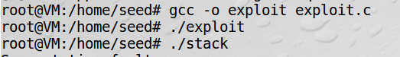

*Figure 26*

The key takeaway from this exercise was the significance of the Stack-Guard protection flag, which would have prevented any buffer overflow vulnerability attack to occur in the first place.

**Task 3 Defeating Dash’s Countermeasure**

The final task involved compiling the dash_shell_test.c file with the setuid(0) line being committed out (Figure 28). The aim of this task was to get access to the root shell, by defeating the dash’s privilege drop countermeasure. Firstly to invoke the dash program the symbolic link /bin/sh was modified to point to /bin/dash (Figure 27).

*Figure 27*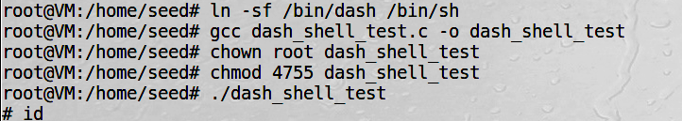

*Figure 28:*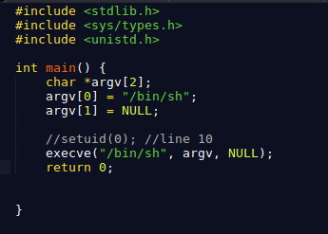

It was observed that executing this code yielded a UID that did not have root shell privileges (Figure 29). This is expected as the real UID and the effective UID are equal and no root shell prompt was observed, hence it can be concluded that the privilege was dropped due to the dash’s counter measure.

*Figure 29:*

*Figure 30:*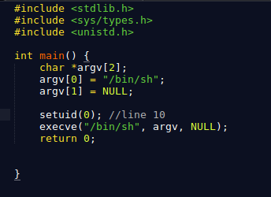

By uncommeting the line 10 of setuid and recompiling the program, this time something different was observed (Figure 31). This time the real UID is root (0) and the effective UID is different seed (1000). It was observed that there was a root prompt, given the real and expected UID both differ. Hence the dash countermeasure was able to be defeated with the privileges not dropped when they should have been dropped. Thus, the most interesting takeaway was by linking to /bin/dash and setting the UID manually to root shell access by changing the real UID.



*Figure 31*

Furthermore, when doing the attack from task 2 again, this time the assembly code included the invoke of setuid(0) call added in the code (Figure 32). Again for this attack /bin/sh was linked to /bin/dash for this attack to be successful. Again disabling space randomization and re-running the code from task 2 (Figure 33).

*Figure 32:*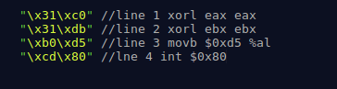

*Figure 33: Re-compiling*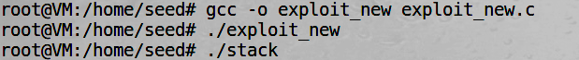

*Figure 34:*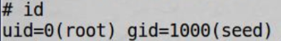

This time it can be observed that when the setuid(0) assembly code command is included in the exploit.c shellcode, root shell access is attained (Figure 34). This was expected as the original exploitation of the buffer overflow vulnerability allowed for root mode. It can also be described by overcoming dash’s countermeasure with setting the UID a root shell can be launched as a root user.

**5.3 Attacks On TCP/IP Protocol**

**Task 1 SYN Flooding Attack**

The first task involved a DoS attack, such that the aim was to “flood” the victims TCP port with SYN requests. An interesting observation was how a flood attack operated. This included understanding the first machine sending a synchronise (SYN) request, which the second machine then responded with a synchronous acknowledgement response (SYN-ACK), finally the first machine responded with an acknowledgement (ACK) in this three way TCP response. The SYN flood attack should send multiple SYN requests by spoofing the IP address to machine two after the SYN-ACK phase where the machine two is awaiting a response with an open port. This spoofing makes it difficult for the server to understand where the attack is originating from. The counter measure to prevent SYN flood attacks involved SYN cookies, turning this mechanism on or off can affect the success of the attack.

The first step involved setting up three virtual machines as Server (10.0.2.5), Attack (10.0.2.6) and Victim (10.0.2.4) (Figure 35).

*Figure 35*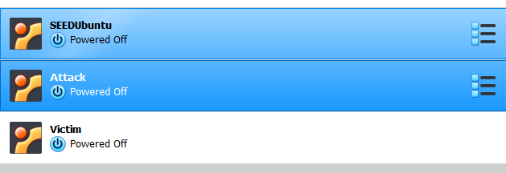

Once the three virtual machines were set up, a connection between the server and victim was established using the telnet command which was successful (Figure 36).

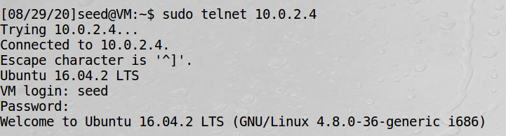

*Figure 36*

Following this connection setup, the next step was to turn off the SYN Cookie counter measure protection, by setting the field value to 0 meaning off (Figure 37).

*Figure 37*

After disabling this countermeasure the connections to the setup server were observed using the netstat command (Figure 38). From this it can be observed on port 23 with IP 10.0.2.4, existed a connection to the server from the victim's machine. This open connection could now be exploited by the attacker

*Figure 38*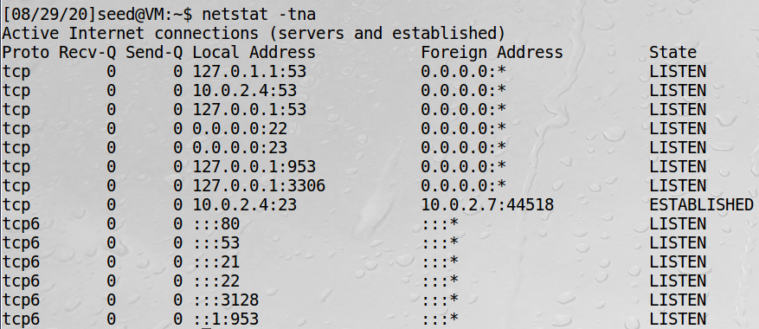

This in the 3 way handshaking process is at the stage after the initial SYN-ACK has been sent, and the attacker can now conduct the SYN flood attack. This was done by typing the following command on the attack virtual machine (Figure 40).



*Figure 40*

This netwox tool can be observed to have sent multiple SYN_RECV, which are half-open connections on the server end. Observations made as the servers queue for requests is now filed with random IP address connections from the attackers virtual machine (Figure 41). 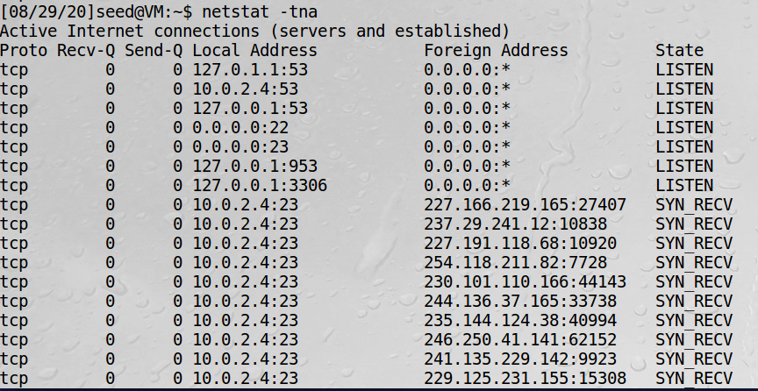

*Figure 41*

To understand whether the SYN flood attack was successful in completing a DoS, another VM was set up (10.0.2.7), and using the telnet (10.0.2.5) command to connect to the service, the following message was observed. This was expected, as without any protective counter measure the servers queue for connection requests was filled by the attack machines SYN flood, hence the denial of connection service to the server.



*Figure 42*

The next part of SYN flooding attack was to explore the effect of enabling the SYN Cookie protection countermeasure. It was expected by doing so that the SYN flood attack from the attack virtual machine would be prevented. This was done by executing the following command on the servers terminal (Figure 43).

*Figure 43*

It can be noted that nor the server, victim and attack virtual machines were reset, and continued running prior to enabling SYN cookie protection. Initial observation of the servers connection illuminated leftover connections from the previous SYN flood attack, which at first was assumed that the queue would be full and new connections couldn’t be established (Figure 44). 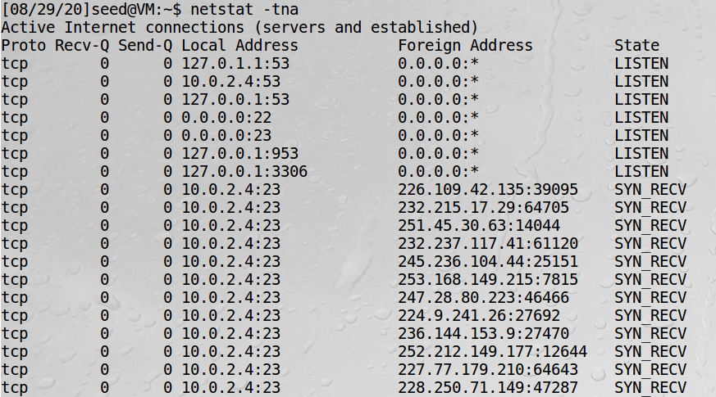

*Figure 44*

When the attack was repeated using the same netwox command (Figure 40), the previous test of whether the server’s queue was full after the attack was again tested. This was done using the telnet command from the victims virtual machine. This time, it was observed that the queue wasn’t full on the server's TCP connection, and allowed another connection to exist between the server and client (Figure 45). The explanation for this would be on the servers connections nothing is established until the final ACK is sent from the victim. With this protection the queue in the server's connections is not flooded because the attack machine is still at the SYN-ACK stage to conduct the attack, hence the victim can connect with the queue not full [1].

*Figure 45:*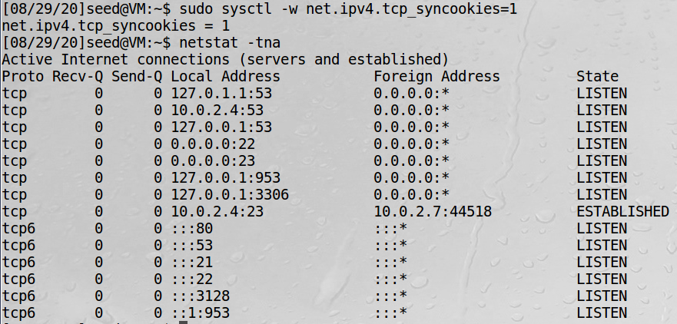

**Task 2 TCP RST Attacks on Telnet and SSH Connections**

The second task consisted of conducting a TCP RST attack on both Telnet and SSH connections. The aim of this task was for the attack machine to spoof an RST packet between two connected machines. The first part included an attempt to launch the RST attack on a telnet connection between two machines. To do so three virtual machines were set up with specific IP addresses (Figure 46).

*Figure 46:*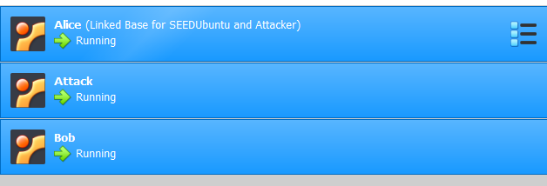

After creating the three virtual machines of the attacker (10.0.2.7) and the victim Alice (10.0.2.4) and Bob (10.0.2.8). The first step involved establishing a telnet connection between Alice and Bob, from Bob's virtual machine a telnet connection was created (Figure 47).



*Figure 47:*

After establishing the telnet connection the attack virtual machine utilized the netwox 78 command (Figure 48). It was observed that by executing this command in the attackers virtual machine that the recipient of the Alice and Bob connection would be Bob. Furthermore, it was interesting to observe that the sent spoofed RST packets used the host Bob (10.0.2.8) to then use the IP address of Alice (10.0.2.4) to construct the RST packets to break the connection between the two machines.

*Figure 48:*

Whilst this attack was taking place, the wireshark tool in the SEED Ubuntu environment was opened and ran to track ‘any’. It can be observed that after viewing the wireshark (Figure 49) of spoofed TCP RST packets

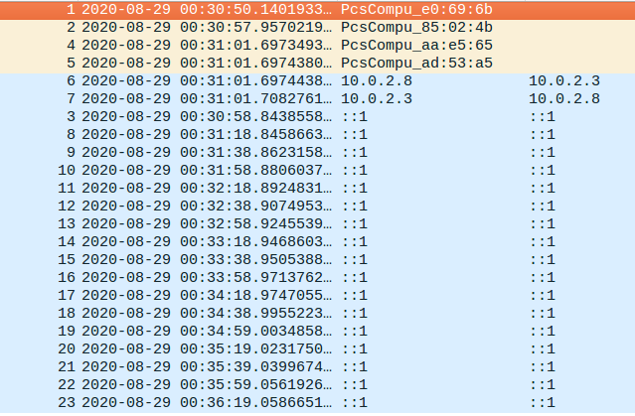

*Figure 49:*

The final step of the telnet attack was to determine if the attack was successful or not. This involved returning to the terminal for the Bob and Alice established connection, which both had displayed the same message of the connection being terminated (Figure 50). Interestingly even though neither Alice, nor Bob requested the telnet connection to be closed, it was closed by the attacker. The key surprise was the ease of destroying a connection between two entities, once the RST TCP packets are correctly constructed. The explanation for this was that the reset packet header for the telnet connection in the RST TCP packet from the attacker had a field which was set to reset the connection between the two machines [2].

*Figure 50:*

The second part of the TCP RST attack involved attempting to disrupt the SSH connection between two entities. To do so, likewise with the telnet an SSH connection was set up between the two victims of Bob and Alice (Figure 51). By entering the following command below in Alice’s (10.0.2.4) virtual machine, an SSH connection was established with Bob (10.0.2.8).

*Figure 51:* 

Once this connection was created between the two machines, the TCP RST attack was again launched from the attack virtual machine using the following command. This time, it can be observed by noting the port number of the victim Alice as port 22, the TCP RST attack was launched using the IP for Bob.



*Figure 52:*

Similar to the attack on telent, by specifying the port number and the spoof IP of the sender machine, the TCP RST packets could be again sent to the victim Alice. As observed in the Wireshark recording the packets were successfully sent to the desired port 22 (Figure 53). Furthermore, similar to the talent attack in returning to the SSH terminal connection between Alice and Bob. It was observed again that the connection was closed by a foreign host (Figure 50). The explanation for this again was that the reset packet header for the SSH connection in the RST TCP packet from the attacker had a field which was set to reset the connection between the two machines [2].

*Figure 53:*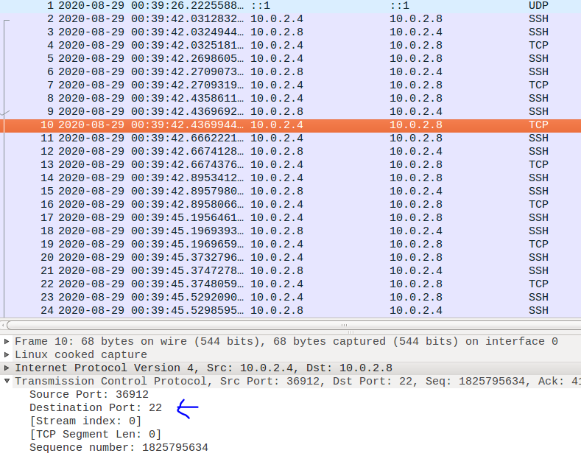

**Task 3 TCP RST Attacks on Video Streaming Applications**

The final TCP/IP lab task involved conducting the TCP RST attack on a video streaming application on the LAN. The purpose of this task was to understand the effect of disrupting TCP sessions between the victim and server. The first step involved the victims virtual machine Alice (10.0.2.15) establishing a TCP connection to any server. In this case the server was selected as the video streaming application Youtube, to establish the LAN TCP connection (Figure 54).

*Figure 54*

Once the TCP connection was established, the victim's virtual machine Alice selected a video on the video streaming site to be played (Figure 55). The observation made was that the video was playing with no issues at a standard 720p resolution.



*Figure 56:*

Once the victim and streaming platform TCP connection was set up, the TCP RST attack was then able to take place. This involved firstly setting up the attack virtual machine attack (10.0.2.7). Likewise with the attacks on Telnet and SSH, the netwox command was again used, with the IP address of the victim Alice (Figure 57).

*Figure 57:*

Explaining this netwox command, the attack virtual machine will send the TCP RST packets which are now sent to the victim Alice to replace the expected TCP packets from the video streaming platform. The observed impact of these RST packets is a broken TCP connection, with the original video ‘buffering’ as no new packets are sent to continue to play the video (Figure 58).

*Figure 58:*

As well as observing on the victim's machine Alic the video buffering, it was also observed in the Wireshark for Alice’s connection to the TCP RST attack (Figure 59). The red highlighted rows are the RST packets which are disrupting the TCP connection between Alice and the Youtube video streaming server.

*Figure 59:*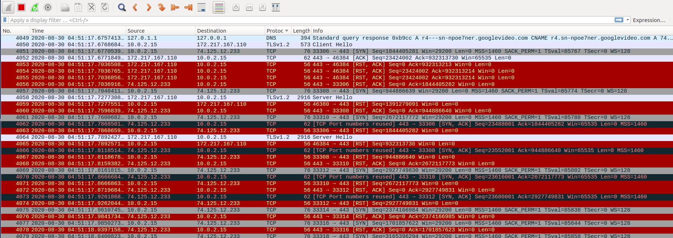

Extending this RST TCP attack the curiosity existed as to what the outcome would be if the attackers virtual machine stopped running the netwox command. This curiosity was explored by ending the netowx RST TCP attack in the attackers virtual machine terminal. The expectation was that victim Alice would need to restart the connection immediately with the Youtube server by either a shutdown or change in IP (Figure 60).

*Figure 60:*

*Figure 61:*

It was observed returning to the victims browser by simply doing nothing. The video stopped buffering, and continued to play the video before the RST TCP attack (Figure 61). The explanation for this is that since no more RST packets are being sent to the victims virtual machine, Alice can continue to receive the correct packets in the TCP connection with Youtube in order to play the video. This normal TCP connection is also observed in the Wireshark feed (Figure 62)

*Figure 62:*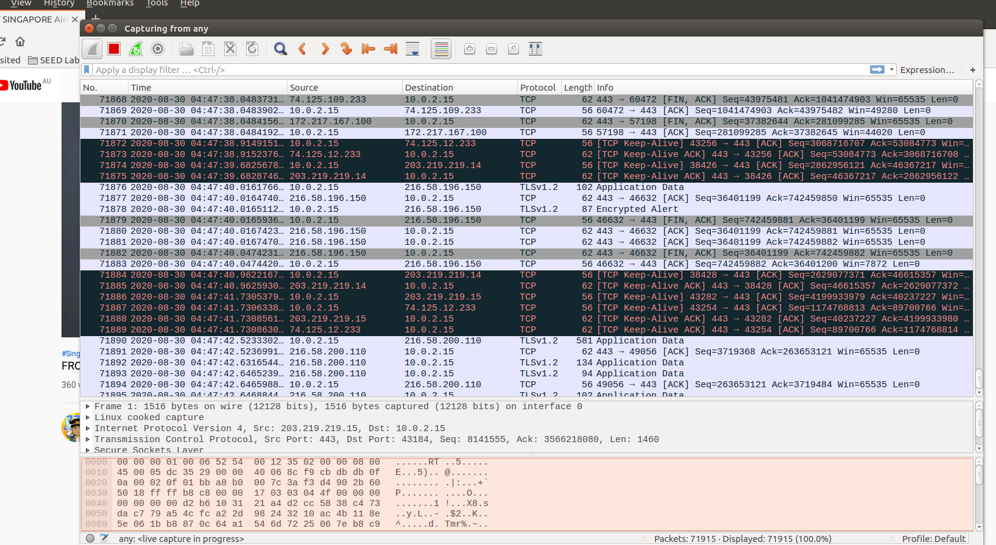

The key learning takeaway from this was the ease of disrupting a video stream from the attackers perspective using the netwox command. As well as the significance of countermeasures between a video streaming server provider and viewer.

**6.0 REFERENCES**

[1]"SYN cookies", *En.wikipedia.org*, 2020. [Online]. Available: https://en.wikipedia.org/wiki/SYN_cookies. [Accessed: 09- Sep- 2020].

[2]"How does a TCP Reset Attack work? | Robert Heaton", *Robert Heaton*, 2020. [Online]. Available: https://robertheaton.com/2020/04/27/how-does-a-tcp-reset-attack-work/. [Accessed: 09- Sep- 2020].

**4.0 References**